SUBMILLIMETRON project

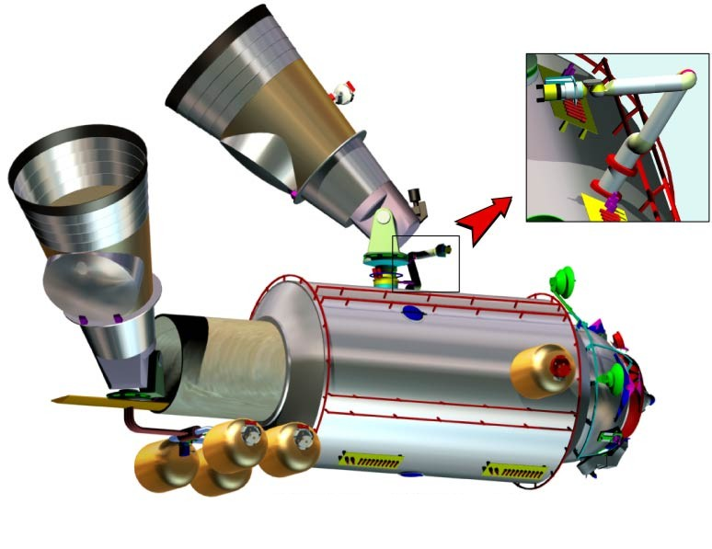

Submillimeter Wave Cryogenic Telescope
for the Russian Segment of the International Space Station.
The Submillimetron is the project of the space telescope for astronomical studies at the submillimeter and infrared wavelengths using facilities of the Russian segment of the International Space Station (ISS). The concept of Submillimetron telescope includes a 60 cm mirror telescope cooled to liquid helium temperature combined with a new type of supersensitive microbolometers arrays. This combination gives unique possibility to realize background limited sensitivity in the spectral minimum of the extraterrestrial background electromagnetic radiation around frequency 1 THz. This region is between peaks of galactic dust emission and extragalactic cosmic microwave background (CMB) measured by COBE satellite. The angular resolution about 1 arcmin and field of about 1º are similar to IRAS satellite survey, but more then order of magnitude better sensitivity about 10⁻¹⁸ W Hz^{-1/2} and another spectral region permits reveal in full sky survey sufficiently more new astrophysical objects. For following space missions FIRST, PLANK, IRIS these results will give useful complementary information of measurements with different angular resolution in another spectral regions. Next feature of the project is the concept of free flying instrument with periodic docking to ISS. Unlike to the usual concept of an autonomous mission this one gives possibility to combine low cost with reliability, refilling, repairment and maintenance. The initiative of the Project was done in Astro Space Center of the P.N. Lebedev Institute after discussions with NASA and JPL, supported later by the Russian Academy of Sciences. The proposal was undertaken to feasibility study in S.P. Korolev Rocket Space Corporation Energia and approved by the Russian Space Agency for the 2-d stage of ISS realization after years 2004 - 2005.
The objectives of the Submillmetron Project.
The objects of an astronomical study in submillimeter and infrared wavelengths are the "cold" components of the matter in the Universe (3ºK radiation relic of Big Bang, extragalactic sources on the stage of star birth burst, dust in the Solar System, in the Galaxy). The primary goal is to conduct a submillimeter wave full sky survey, and to perform studies of the spectra of astronomical sources and their variability, to conduct cosmological studies (study of the anisotropy of the cosmic microwave background radiation and search for Lyman-alpha line at the epoch of recombination and secondary heating). The secondary goal is to provide a test bed to perform the technological experiments needed to develop follow-on projects.
Experiment configuration
The main configuration of the Submillimetron in the process of observation is free flying spacecraft (FFS) carrying telescope payload with deployed screens and fully active cryogenic systems. The FFS has docking equipment for work in conjunction to ISS on stages of delivery, deployment , and if necessary for refilling, repairment and maintenance. The FFS made on the base of Progress cargo-ship has also possibility to arrange auxiliary observing instruments, for example heterodyne instrument for high resolution spectrometry and interferometry with noncooling mirror up to 1.5 m. The orbit of the FFS can be distant enough from ISS to solve problems of contaminations and excessive infrared radiation and shadowing. Submillimtron telescope payload consists of Cryogenic Telescope with optics and cryogenics systems and Data Registration and Processing Unit with electronics and power supply systems.

Orbit: circular orbit at an altitude of approximately 444 km with a 51.6º inclination.
Delivery to initial ISS orbit: modified cargo-ship Progress

Payload: the Submillimeter Cryogenic Telescope
- mass: 300 kg
- power consumption: 400 W
- size (deployed configuration)
- pointing: ± 15 arc sec in survey mode (reconstructed)
- pointing data rate 1 per 10 sec
data output: 1 Gbyte/day
The Cryogenic Telescope parameters are:

Diameter: D=0.6 m
Optical system: two-mirror Cassegrain

Cooling:
- telescope mirrors: <5 K
- bolometers: 0.1 K

Wavelengths:
- submillimeter bands: 0.3, 0.4, 0.5, 0. 6, 0.8, 1, 1.5 mm
- infrared bands: 3, 10, 30, 100, 200 μm .
Spectral bandwidth: 20 - 30% of the central wavelength.
Detector arrays:
- in submillimeter bands 2D arrays, 30-10000 elements;
- in infrared bands 1D arrays, 50-200 elements.
Sensitivity of the detectors:
- submillimeter bands: 10⁻¹⁸ W/Hz^{1/2}
- infrared bands: 10⁻¹⁷ - 3x10⁻¹⁶ W/Hz^{1/2}

Angular resolution:
- submillimeter bands: 1-10 min of arc (diffraction limited)
- infrared bands: 1 min of arc (mirrors shape accuracy 20 μm r.m.s.)

Sensitivity of the telescope (integration time = 1 s)
- submillimeter bands: 3-12 mJy
- infrared bands: 6-40 mJy

Block diagram of the Cryogenic Telescope.

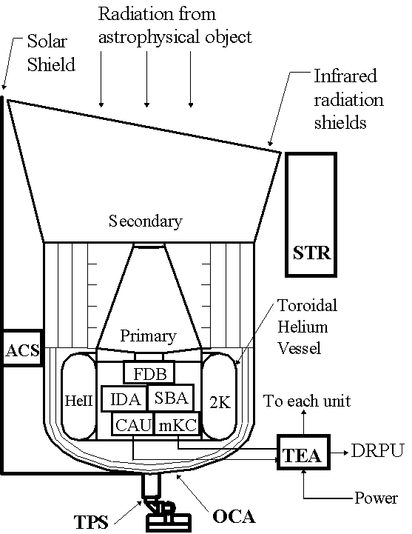
ACS - Active Cooling System, T=20K;
STR - Star Tracker, defines pointing of the telescope;
HeII – superfluid helium vessel^{*)} T=2K, cooling of primary and secondary mirrors;
TPS - Telescope Pointing System;
FDB - Focal Dichroic Beam-splitters assembly;
IDA- Infrared Detector Array;
SBA - Submillimeter Bolometer Array;
CAU - Cool Amplifiers Unit;
mKC - milli-Kelvin Cooler (T=100 mK);
TEA – Telescope Electronics Assembly,
DRPU - Data Registration and Processing Unit.

Notes: ^{*)} toroidal shape of vessel correspond to precooled launch configuration, in warm start version the shape is almost spherical.

The participants of the Submillimetron project team are:
- N.Kardashev (nkardash@asc.rssi.ru), V. Gromov, A. Trubnikov (gro@asc.rssi.ru) Astro Space Center (ASC), Russia, http://www.asc.rssi.ru;
- L.Kuzmin (Kuzmin@fy.chalmers.se)) Chalmers University (CTH), Sweden, http://www.chalmers.se;
- M.Tarasov (tarasov@hitech.cplire.ru) Institute of Radio Engineering and Electronics (IREE), Russia, http://www.cplire.ru/;
- A.Andreev (andreev@kapitza.ras.ru) P.L.Kapiza Institute of Physical Problems, (KIPP), Russia, http://www.kapitza.ras.ru/;
- L.Gorshkov (Leonid.Gorshkov@rsce.nasa.ru), S.P.Korolev Russian Space Corporation “Energia” (RSC), Russia, http://www.energialtd.com/rsc.htm;
- V.Altunin (valtunin@ jpl.nasa.gov), Jet Propulsion Laboratory (JPL), USA, http://www.jpl.nasa.gov/;
- I.Maslov (imaslov@iki.rssi.ru) Space Research Institute (IKI), Russia, http://www.iki.rssi.ru.

