P3. SIN junction thermometers using e-beam lithography and thermal evaporation
in Direct Write mode.
Gustav Pettersson and Leonid Kuzmin

Thermometry is a cornerstone in low temperature physics as it is extremely important not only to reach the low temperature but also to be able to measure it.
SIN junction thermometer uses a primary thermometry method which is only few years old. This kind of thermometer is an on-chip thermometer which consists of a tunnel junction between normal metal and a superconductor (SIN – junction). Its current-voltage characteristics have the very important property that they depend on the temperature.
The SIN thermometers are attractive for temperature measurements between 20 mK and
10 K due to a number of features such as their primary nature, small size, low power dissipation, high accuracy, and high speed of operation.

The goal of the project is to develop, manufacture and measure on-chip SIN thermometers.
The samples will be fabricated in MC2 process lab using three steps of e-beam lithography in Direct Write mode and subsequent thermal evaporation at 90º after each exposure and development.

The next step in improvement of accuracy of measurements is related to relative decreasing the noise of an amplifier by increasing the number of tunnel junctions.
Therefore, chains of 10 – 30 junctions should be fabricated in order to achieve highest responsivity and to minimize influence of the noise of the amplifiers in the measurement setup. Optimal topology of thermometer should be elaborated and standard measurement setup should also be designed.
The results will be summarized in the report and could be presented for publication.

Publication of previous group:
E. Otto, G. Petterson, D. Gustaffson, L. Kuzmin, “Cryogenic Thermometer based on SIN tunnel junction array”, submitted to SUST

The general information about FKA190 course in Bolometer Group can be found at
http://fy.chalmers.se/~kuzmin/TEACHING/FKA190-MICROFABRICATION/

Auto CAD layout: 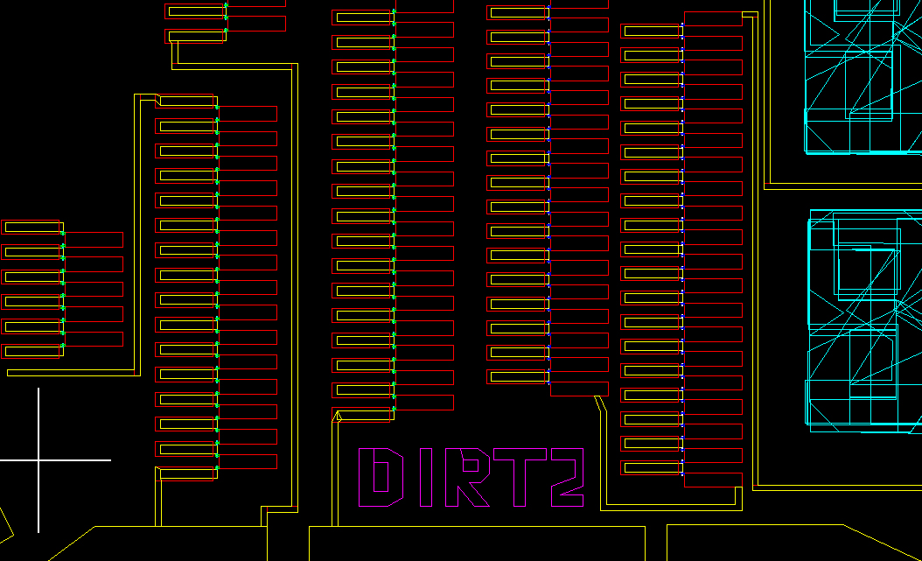

The chip after developement of the second layer:
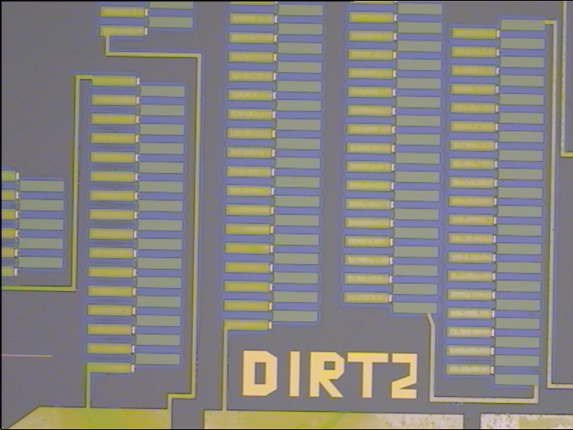

IV-curve of the thermometer:
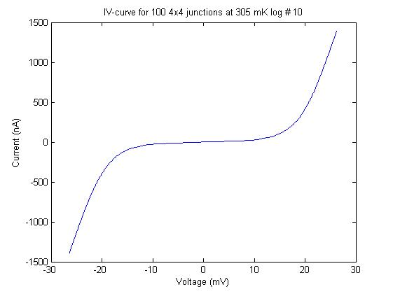

A voltage as a function of temperature for a bias current:
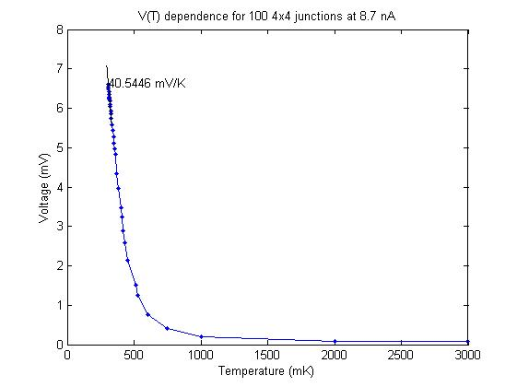
The pictures are made by a student of the previous term Gustav Pettersson [guspet@student.chalmers.se]

